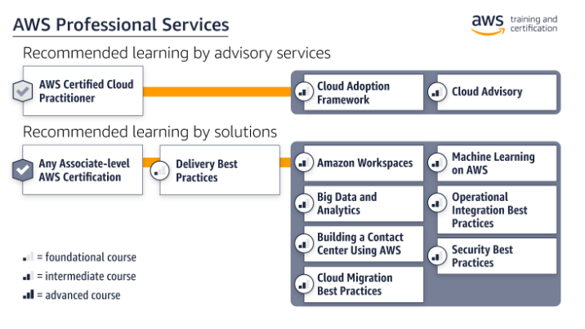

# Training by Advisory Services

|  |  |  |  |
| --- | --- | --- | --- |
| Training | Type | Duration | Register |
| AWS Professional Services: Cloud Adoption Framework | Classroom | 1 day | [Find classroom training](https://partnercentral.awspartner.com/LmsSsoRedirect?RelayState=%2ftraining%2fschedule%3fcourseId%3d11561&src=path-pro-serv) |
| AWS Professional Services: Cloud Advisory | Classroom | 2 days | [Find classroom training](https://partnercentral.awspartner.com/LmsSsoRedirect?RelayState=%2ftraining%2fschedule%3fcourseId%3d19216&src=path-pro-serv) |
| Free digital training |  |  | [Start learning for free at aws.training](https://aws.amazon.com/training/) |

# Training by Solutions

|  |  |  |  |
| --- | --- | --- | --- |
| Training | Type | Duration | Register |
| AWS Professional Services Delivery Best Practices Bootcamp | Classroom | 3 days | [Find classroom training](https://partnercentral.awspartner.com/LmsSsoRedirect?RelayState=%2ftraining%2fschedule%3fcourseId%3d10011&src=path-pro-serv) |
| AWS Professional Services: Big Data and Analytics | Classroom | 2 days | [Find classroom training](https://partnercentral.awspartner.com/LmsSsoRedirect?RelayState=%2ftraining%2fschedule%3fcourseId%3d21361&src=path-pro-serv) |
| AWS Professional Services: Building a Contact Center with AWS | Classroom | 1 day | [Find classroom training](https://partnercentral.awspartner.com/LmsSsoRedirect?RelayState=%2ftraining%2fschedule%3fcourseId%3d19217&src=path-pro-serv) |
| AWS Professional Services: Cloud Migration Best Practices | Classroom | 1 day | [Find classroom training](https://partnercentral.awspartner.com/LmsSsoRedirect?RelayState=%2ftraining%2fschedule%3fcourseId%3d19553&src=path-pro-serv) |
| AWS Professional Services: Deployment Best Practices for Amazon Workspaces | Classroom | 1 day | [Find classroom training](https://partnercentral.awspartner.com/LmsSsoRedirect?RelayState=%2ftraining%2fschedule%3fcourseId%3d20034&src=path-pro-serv) |
| AWS Professional Services: Machine Learning on AWS | Classroom | 1 day | [Find classroom training](https://partnercentral.awspartner.com/LmsSsoRedirect?RelayState=%2ftraining%2fschedule%3fcourseId%3d21099&src=path-pro-serv) |
| AWS Professional Services: Operational Integration Best Practices | Classroom | 1 day | [Find classroom training](https://partnercentral.awspartner.com/LmsSsoRedirect?RelayState=%2ftraining%2fschedule%3fcourseId%3d19554&src=path-pro-serv) |
| AWS Professional Services: Security Best Practices | Classroom | 2 days | [Find classroom training](https://partnercentral.awspartner.com/LmsSsoRedirect?RelayState=%2ftraining%2fschedule%3fcourseId%3d19552&src=path-pro-serv) |